Alexander Baldree
08/11/26
Module 1.3 Assignment
CSD440

GitHub Link:
https://github.com/Panda-Alex21687/CSD440
XAMPP Apache Running
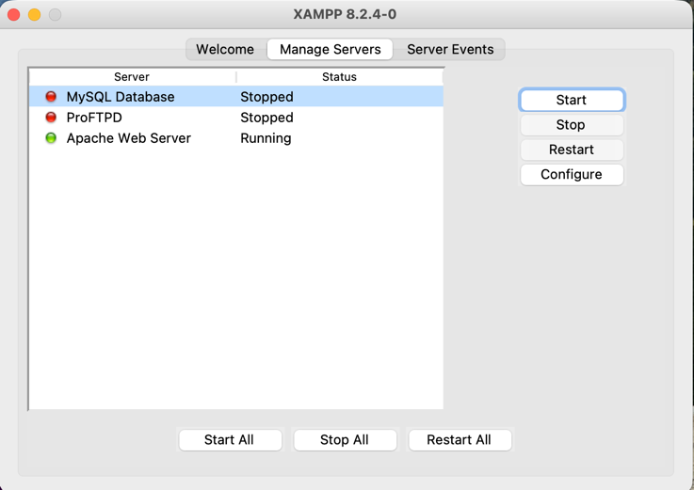

XAMPP Installed Successfully:
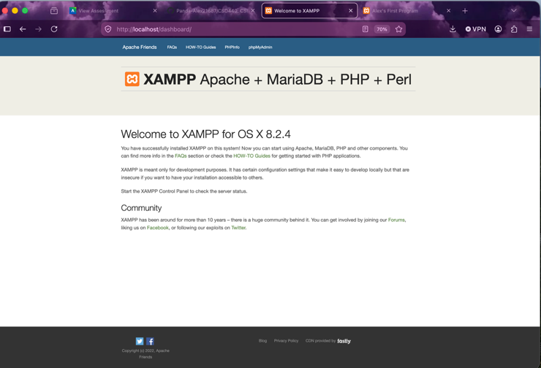

AlexFirstProgram.php Running and in correct folder:
